Polly-All Lead Free Ink Chart
* Denotes light fast colors
** Denotes mixing two components

Standard Colors
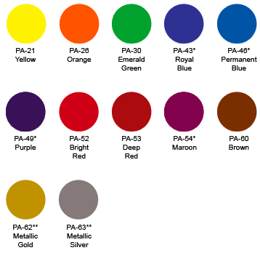
Mixing Colors
